
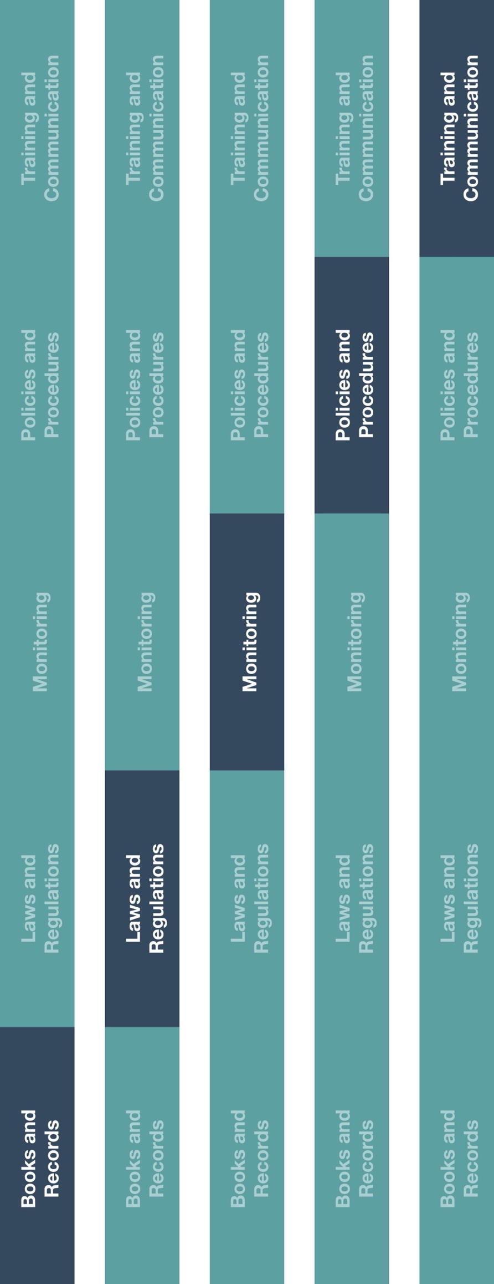
Indirect Channel
Resource Center





Other documentation to consider
- High Risk Third-Party Vendor/Supplier Contract Guidance
*Please consider all local industry code(s) (e.g., AdvaMed) and local laws when interacting with healthcare professionals or government officials
Instructions
- Customize the highlighted sections of the High Risk Third-Party Vendor/Supplier Appointment Procedure.
- Apply this procedure to new and existing vendors or suppliers to determine if the new vendor or supplier is in scope for this procedure.
- Communicate the procedure to relevant employee(s), specifically those who identify new business partners, manage business relationships and/or are responsible for issuing payments to vendors.
- Provide training to these employees on how the procedure will be implemented and executed going forward.
Description
The High Risk Third-Party Vendor/Supplier Appointment Procedure details requirements related to identifying high risk third-parties, implementing controls to mitigate risks
associated with them and managing business relationships in a compliant manner.
High risk third-parties include those that may act on your behalf and/or interact with government officials, government entities or healthcare professionals.

Version 1.0
High Risk Third-Party Vendor/Supplier Appointment Procedure
How does this benefit you?
This procedure will help you identify and mitigate third-party risk through defined controls and processes. Additionally, implementing the controls and processes contained herein will help you meet compliance requirements of your manufacturers.

HIGH RISK THIRD-PARTY VENDOR/SUPPLIER APPOINTMENT PROCEDURE
Third-party controls and processes are critical tools to mitigate the risk that our third-parties may pose to the Company. The steps below must be applied to each third-party in scope of this procedure.
HIGH RISK THIRD-PARTY VENDORS/SUPPLIER
While all business partners may present a risk to the Company, for purposes of this procedure, High Risk Third-Parties (“HRTP”) are those third-parties that:
- Act on our behalf or represent [insert company name].
- Perform services in our name; and/or.
- Interact with government officials, government entities or healthcare professionals (“HCPs”) in the course of providing services to the Company. Examples of such third-parties include, but are not limited to, customs brokers, travel agents, vendors assisting with product registration, legal providers, tax advisors and vendors assisting with licenses and permitting.
This procedure does not apply to sub-distributors/agents. For sub-distributors/agents please refer to the Sub-Distributor/Agent Appointment Procedure.

DUE DILIGENCE, CONTRACTING AND ONBOARDING
Prior to any HRTP beginning to provide services to the Company, the following steps must be completed:
- Due Diligence: Once a third-party is identified as an HRTP, due diligence must be conducted on the individual or entity. Evidence of due diligence completion must be maintained. These third-party due diligence procedures, whether conducted by a Company employee or designated service provider, must include:
  - Documentation of the business need for and qualifications of the HRTP.
  - Perform background searches, reputational and adverse media check using internet, legal entity registration, beneficial owner confirmation and credit check.
- Contracting: A valid, legal contract or written agreement must be executed between the Company and each HRTP prior to the provision of any services. The contract must:
  - Be signed on behalf of the Company by the [insert role].
  - Clearly define the contracting entities, services to be provided by the HRTP and contract term.
  - Reflect any relevant fees, rates or prices to be charged and payment terms.
  - Include Anti-bribery Anti-corruption (ABAC) terms and conditions. Refer to the High Risk Third-Party Contract Guidance for additional contracting instructions.
- Onboarding: After due diligence and contracting is complete, the HRTP may be fully onboarded. The HRTP’s name, address, banking information, payment terms, due diligence documentation and executed contract should be provided to the responsible employee(s) to active the new HRTP.

PAYMENTS, VENDOR MAINTENANCE AND TERMINATION
- Payments: Payment to HRTPs should be scrutinized more than payments to other third-parties. Prior to approving any payment to an HRTP, all relevant documentation (including invoice, supporting documents and payment request) must be reviewed by the [Insert role]. Only after documenting the approvals of these individuals in writing may the payment be issued. Payments should only be issued directly to the individual or entity reflected in the HRTP contract.
- Vendor Maintenance: All HRTPs should be evaluated at least [insert time period] to ensure that i) their services are meeting the Company’s business and compliance expectations, ii) their services are still needed by the Company and iii) there have not been any significant changes that would affect the result of the initial due diligence conducted (e.g., change in ownership structure). Specifically, at the time of evaluation:
      - [insert role] should assess whether the Company has paid the HRTP for any services within the previous year. A lack of payment activity may indicate that this HRTP’s services are no longer required and that it can be deactivated.
      - The [insert role] should determine, through research and knowledge of the HRTP, or discussions with the employee(s) that manage the relationship with the HRTP, whether any events have occurred that would necessitate a refresh of previous due diligence conducted.
- Termination: At the time of HRTP termination, the HRTP should be notified, the contract should be declared to be no longer in force and the HRTP’s should be deactivated (i.e., placed on payment hold) following legally required notice period. The Company may also need to notify its manufacturers. The following circumstances (among others) may, at the discretion of the [insert role], require HRTP termination:
      - Breach of contract clauses, including ABAC terms and conditions.
      - Knowledge of reputational issues or adverse media.
      - Underperformance or missed targets/objectives.
      - Judgment that the HRTP’s services are no longer required.

QUESTIONS AND CONCERNS
Should you have questions on how to apply the procedure contained herein or any concerns about any third-party vendor or supplier, you should raise these to your supervisor or [insert role] immediately.

